CS 531 Web Development Technologies

ASSIGNMENT 3

REPORT

By

Ravi Sai Sashank #258317

Divya Pavan Sai Alamuri #255562

**1. HTML/PHP Web pages**

Design and develop Web pages with PHP to process the data from the winestore MySQL database on CS99. You must not assume that the user knows the SQL queries, so your GUI design can’t ask the user to enter the SQL commands.

a. You can create your MySQL account in CS99 using the script at <https://cs99.bradley.edu/~firewall/register.pl>

(You may need to use IE or Firefox instead of Chrome to login and ignore the security warning, since CS99 HTTPS may have some certificate issues at this time.)

b.  Click the [winestore.data](http://hilltop.bradley.edu/~jiangbo/courses/winestore.data) link to download the SQL script to create the database. You can either create the winestore database use the [phpMyAdmin](https://cs99.bradley.edu/myAdminPHP/) or use the following commands:

$mysql –u username –p

 >(type in password)

…

mysql> source winestore.data;

Finally you should add the WineStore web page on your club web site.

2. PHP Scripts

1. Develop a query PHP script **query**.php to do the following: (see code examples on the lecture notes.)  
- Process user query inputs; the query should access data in more than one tables.   
- Send query to winestore MySQL database; use try/catch to display the database and network error messages.   
- Display the query results in HTML5 Tables.

2. Develop a write PHP script **write**.php to do the following: (see code examples on the lecture notes.)  
- Process user inputs command to insert, update, or delete data in more than one tables.   
- Send the command to winestore MySQL database; use try/catch to display the database and network error messages.    
- Display the write results in HTML5 Tables.

1) MySQL:

Creating a MySQL Account:

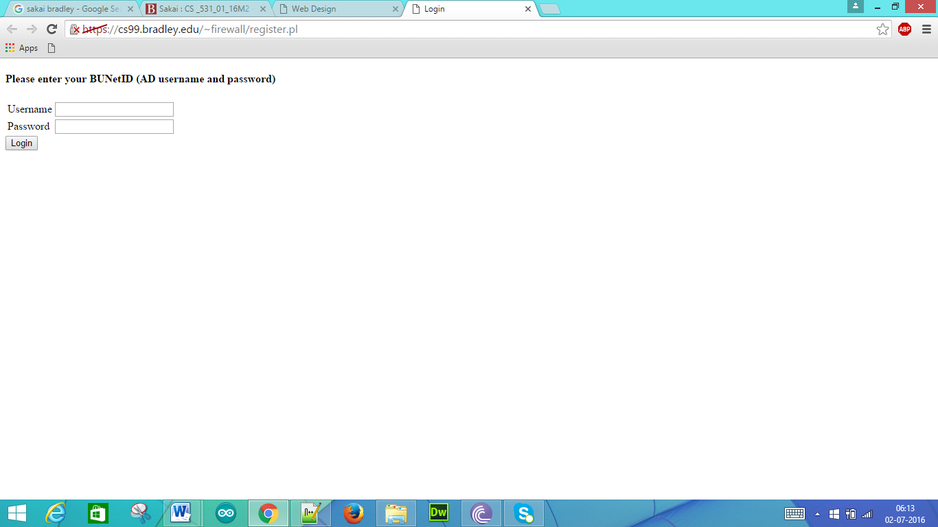

Login Credentials for Database:

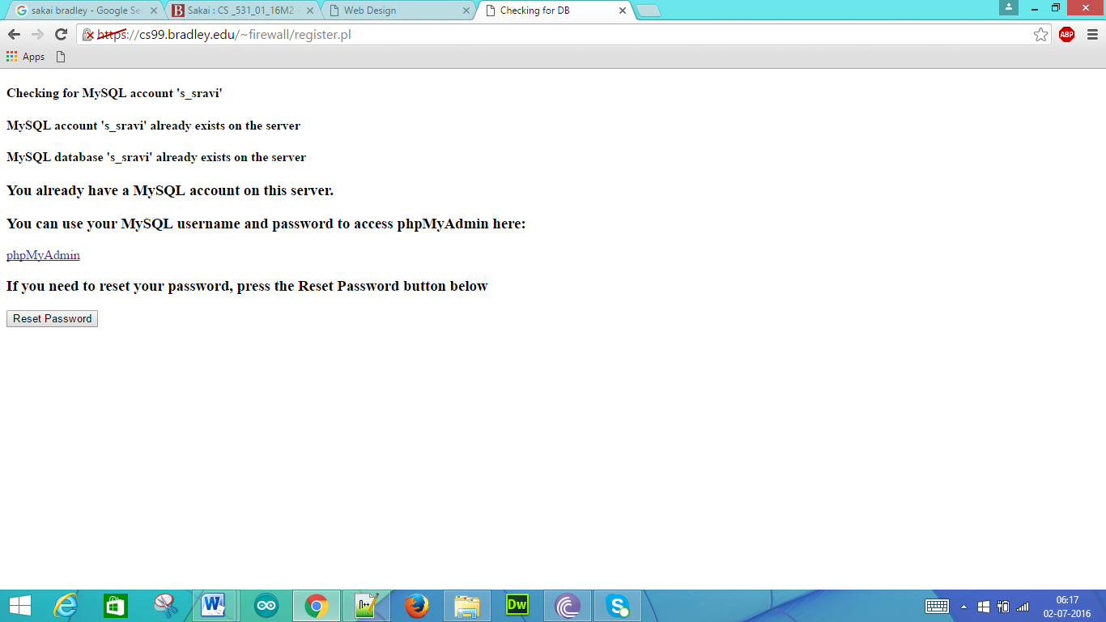

phpMyAdmin Login Page:

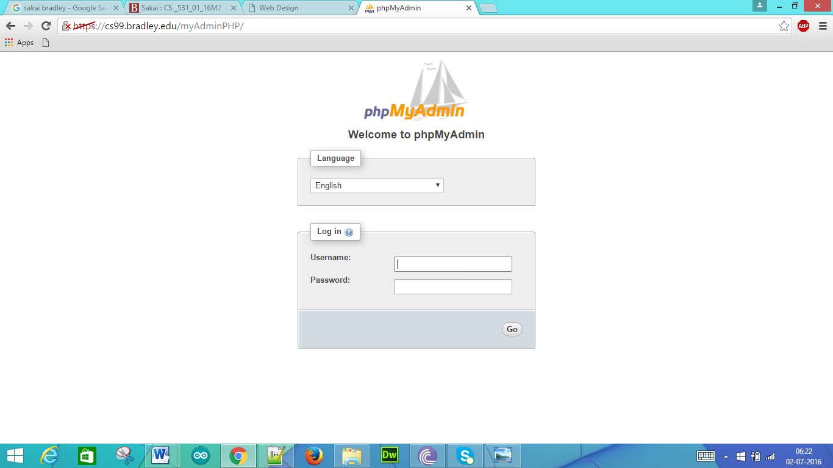

After entering the correct credentials:

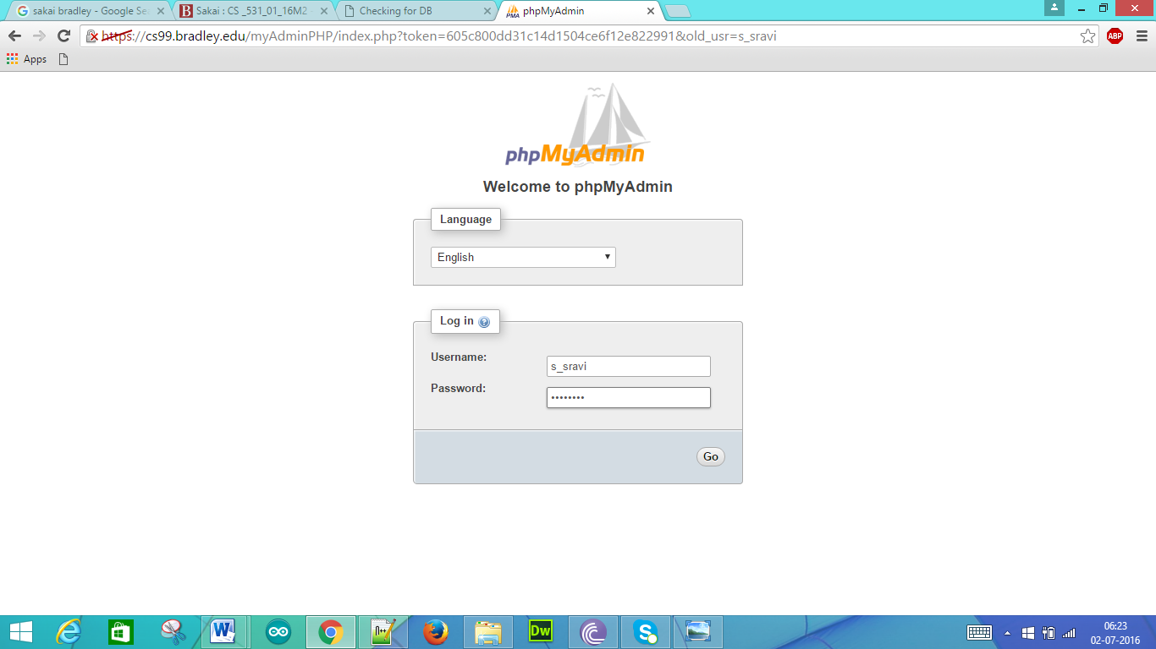

Database structure that has been created:

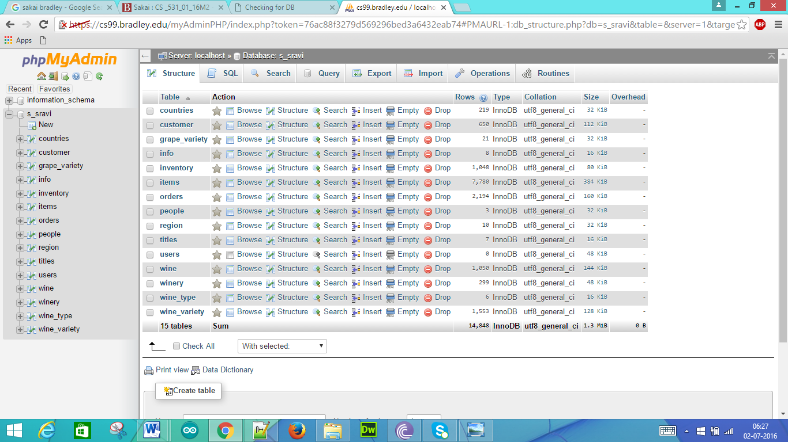

A) Creating Tables from the given Winestore Data

B) Creating a HTML page named index and including select, insert, update, delete tabs

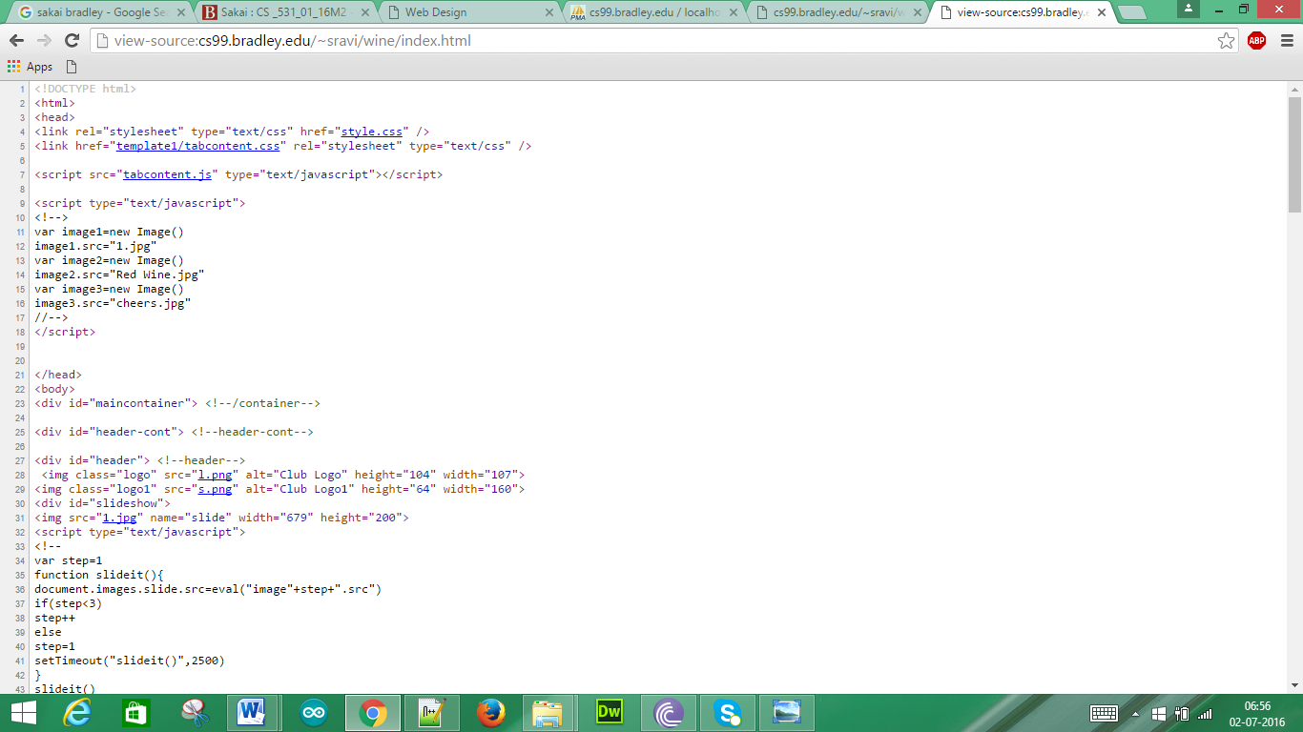

HTML page in the browser:

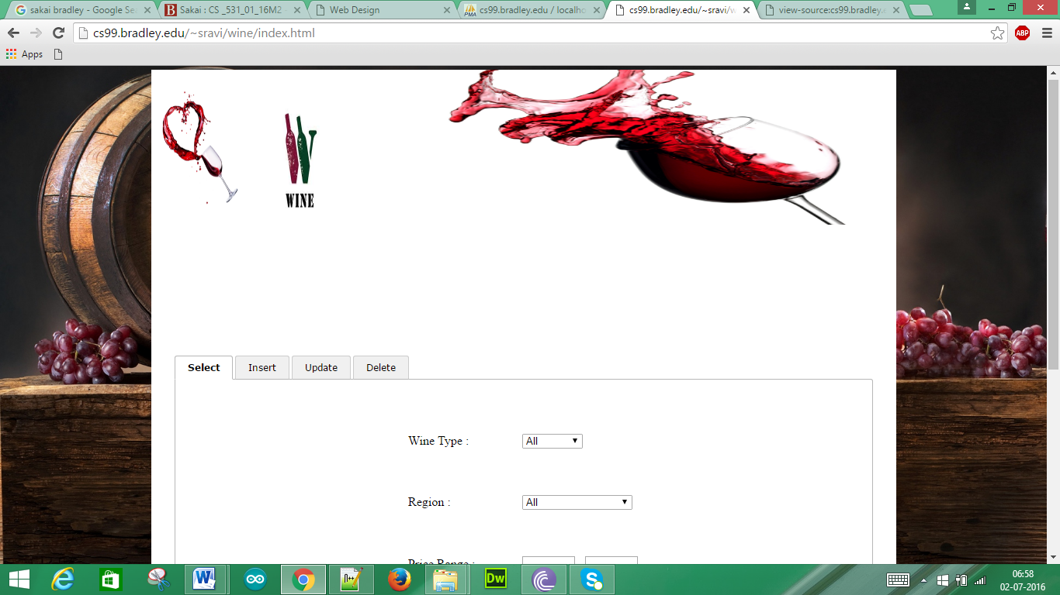

2) PHP Scripts

i) Wine Selection:

Wine Selection HTML Code:

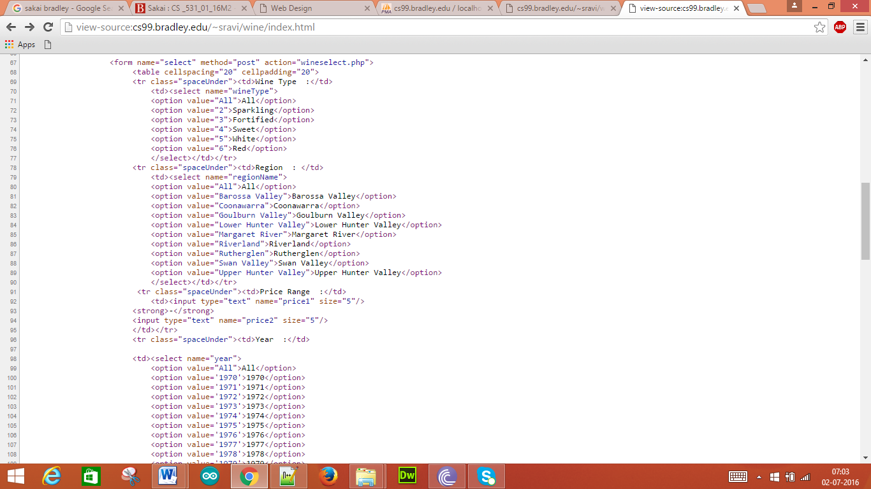

Wine Selection PHP Script:

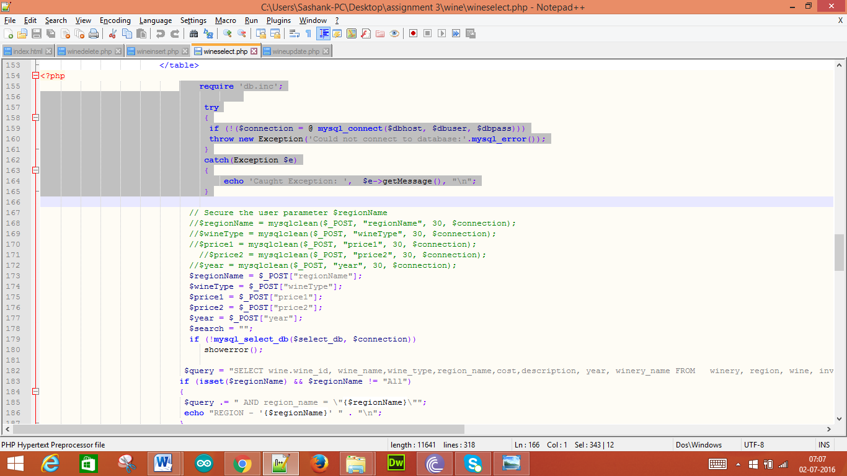

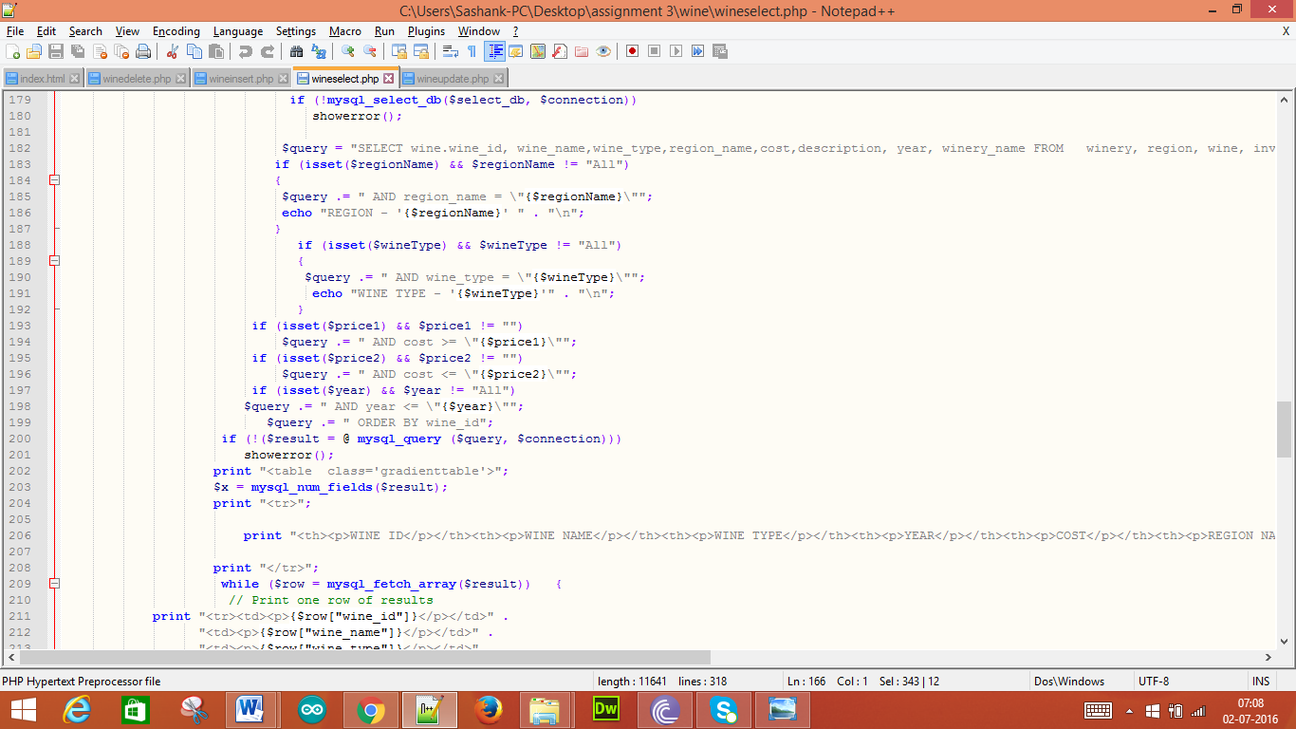

Try and Catch blocks are both included into PHP Script

Wine selection page when no inputs are given:

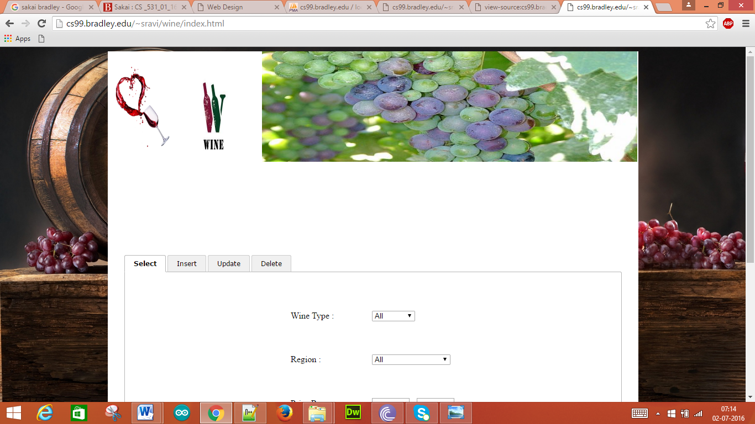

When we provide the inputs to the fields:

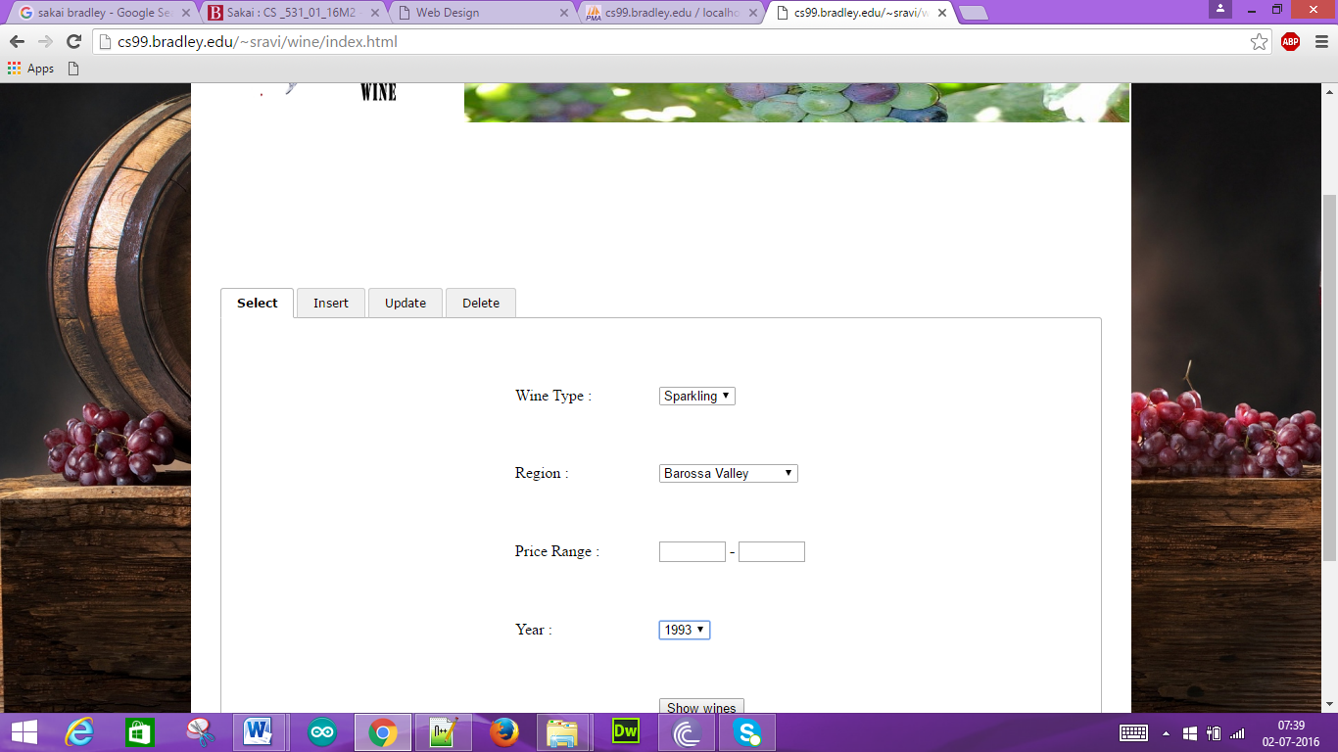

For the above provided inputs we get the following:

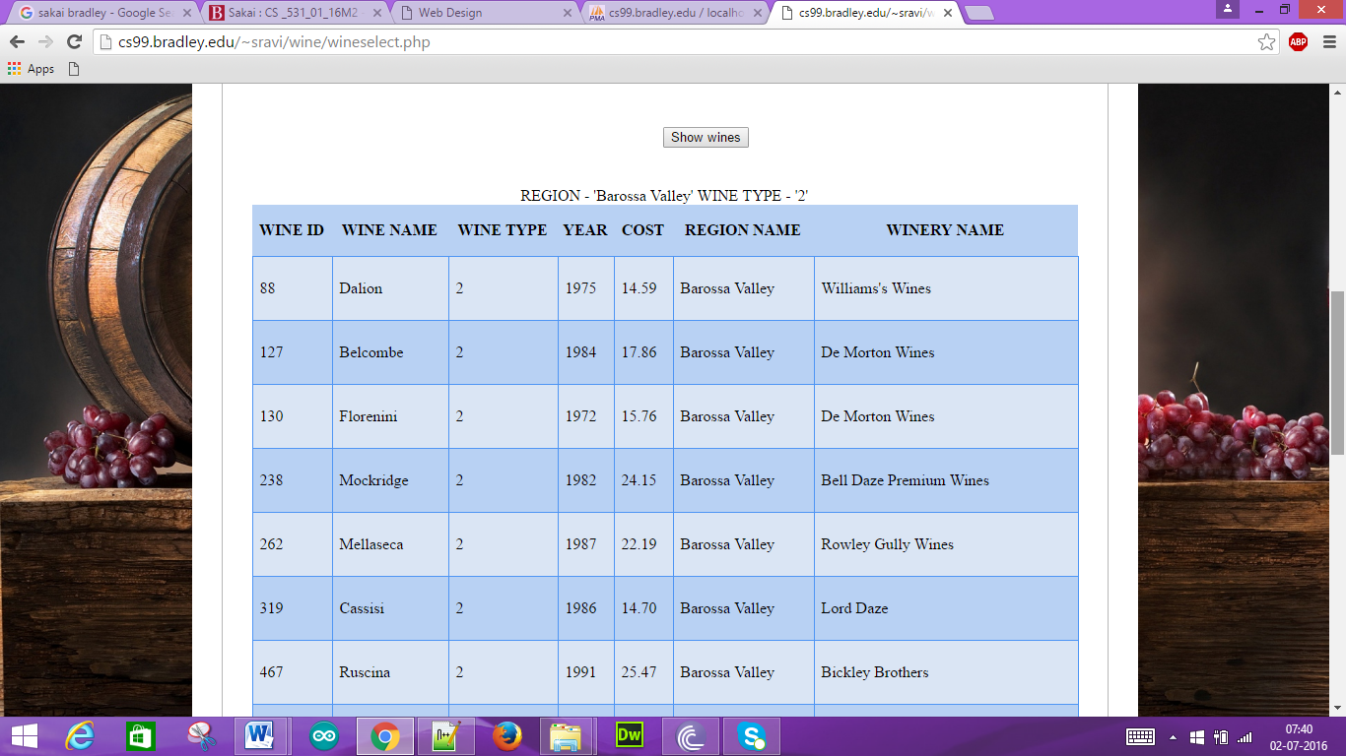

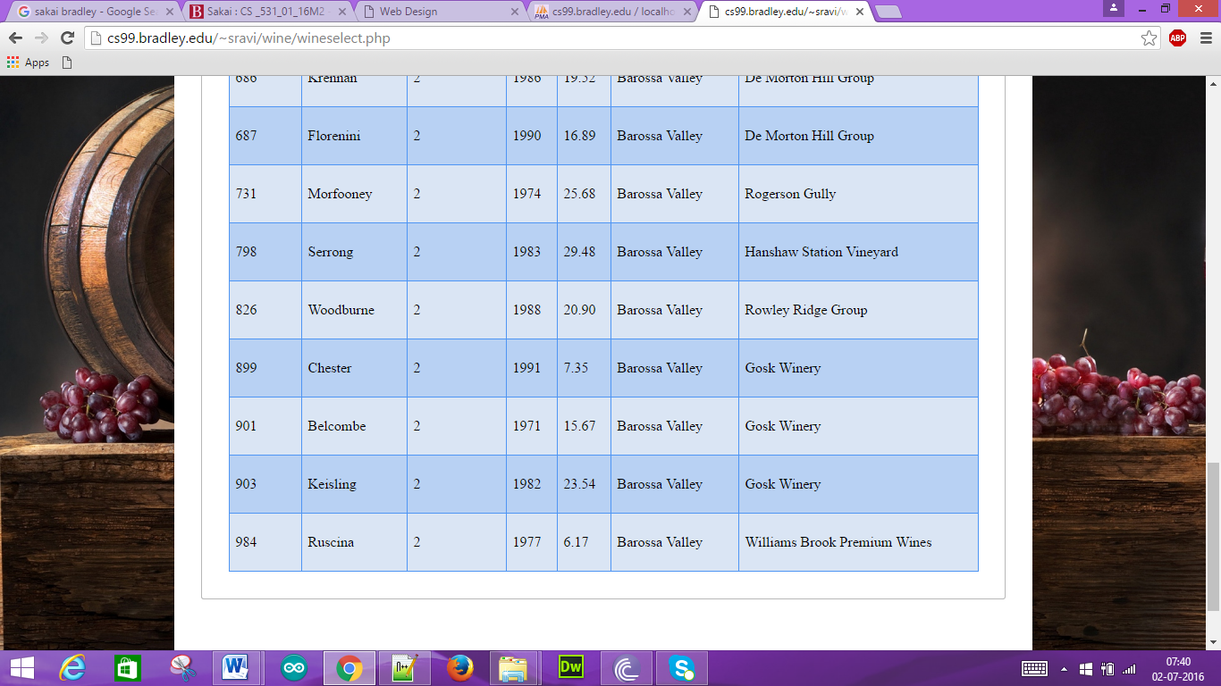

ii) Wine Insertion:

Wine Insertion HTML code:

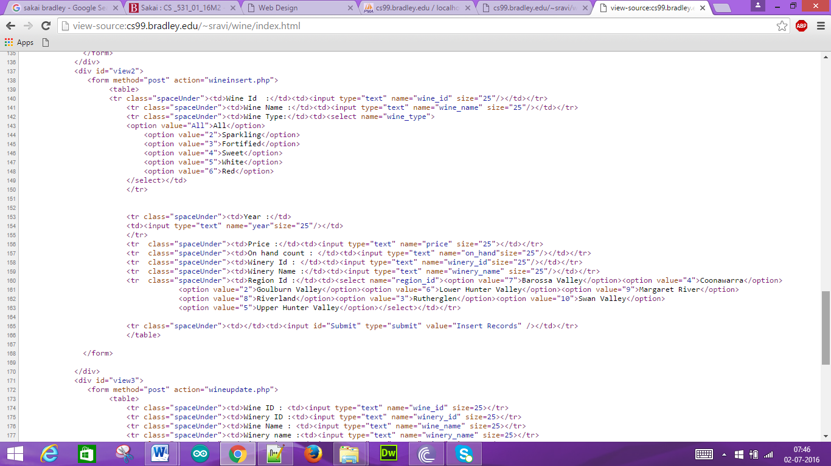

Wine Insertion PHP Script:

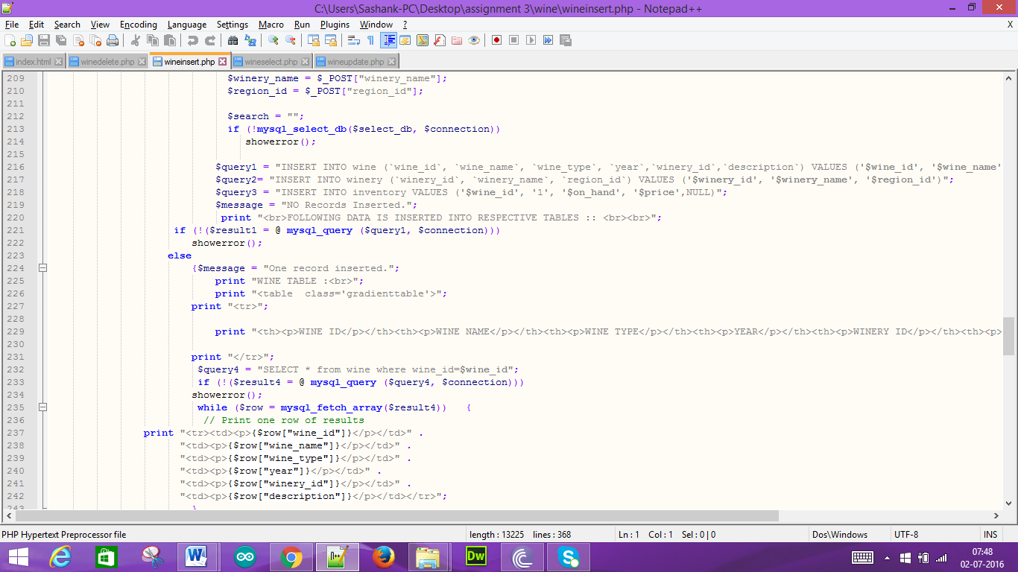

Wine Insertion page without any inputs:

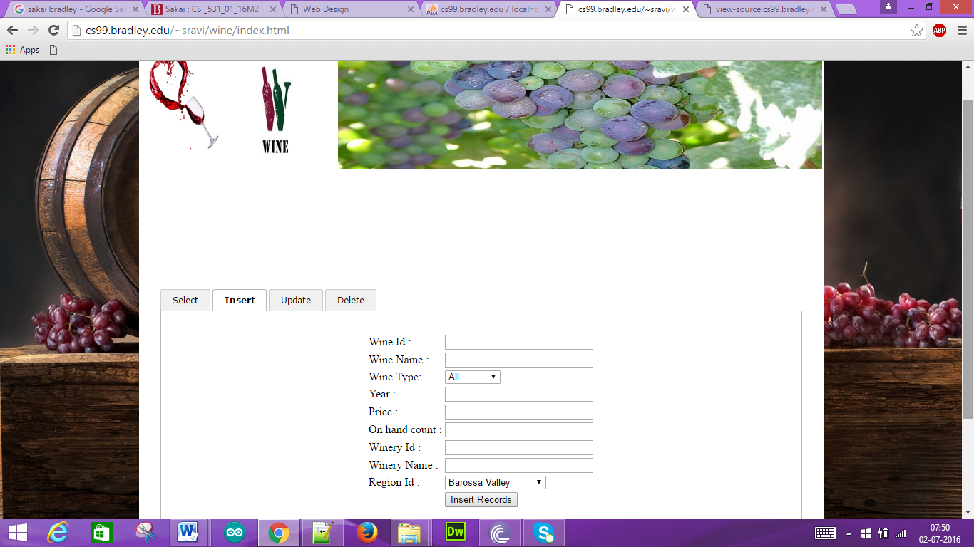

After entering the following data into the fields:

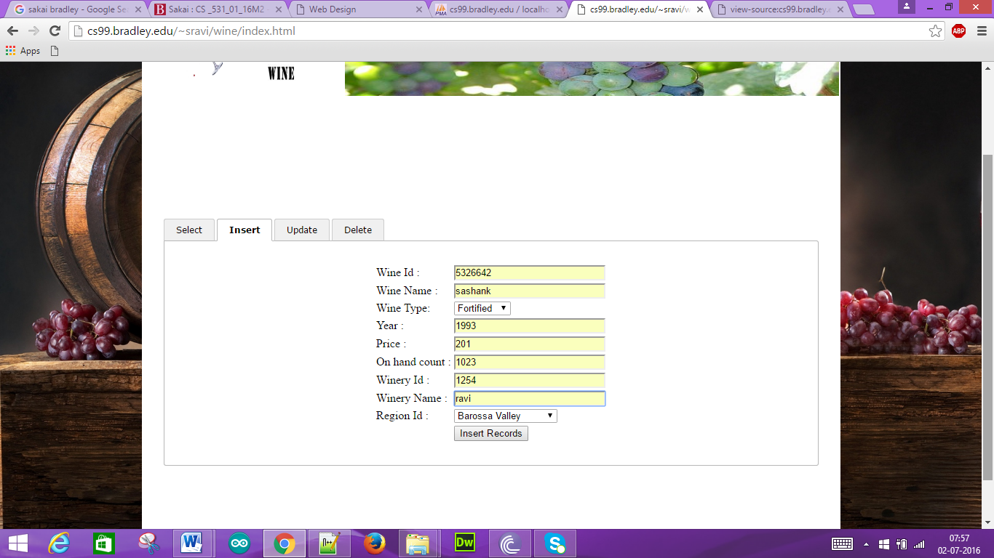

For the above input the data will be inserted and it is shown as follows:

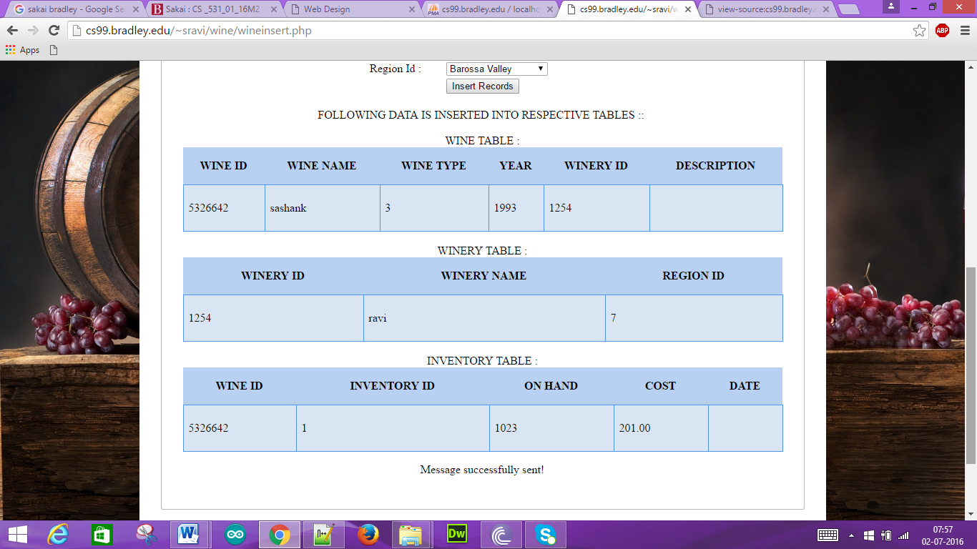

In order to check the data that is inserted we click the “Show wines”:

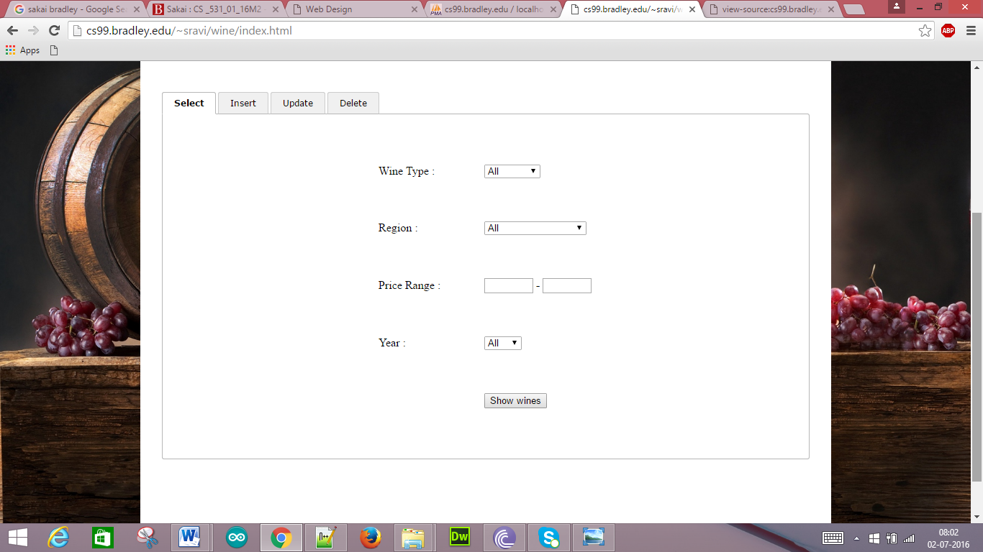

Data that has been inserted is as such in the last row:

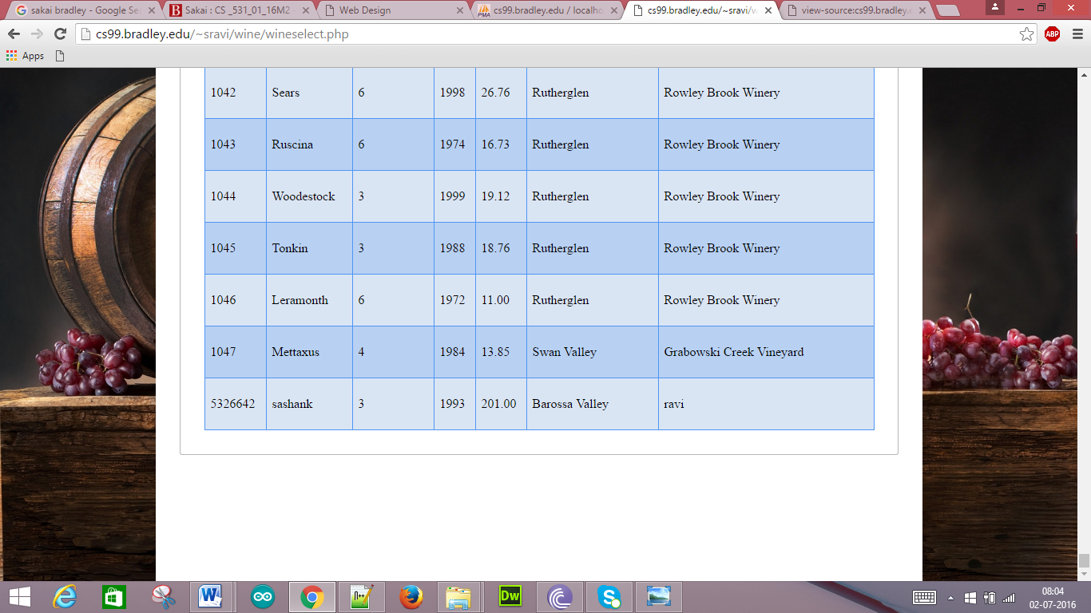

Email Confirmation for this is also given as such:

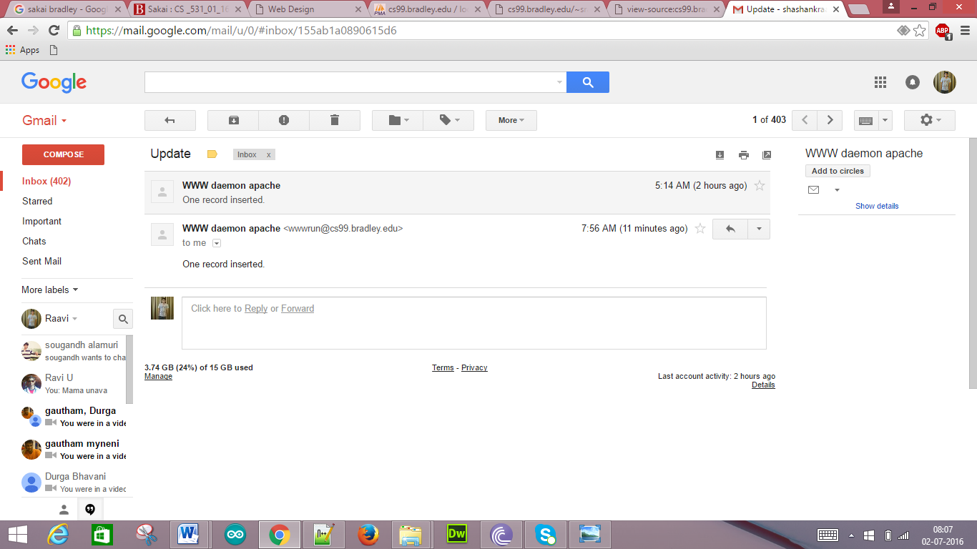

iii) Wine Updation:

Wine Update HTML Code:

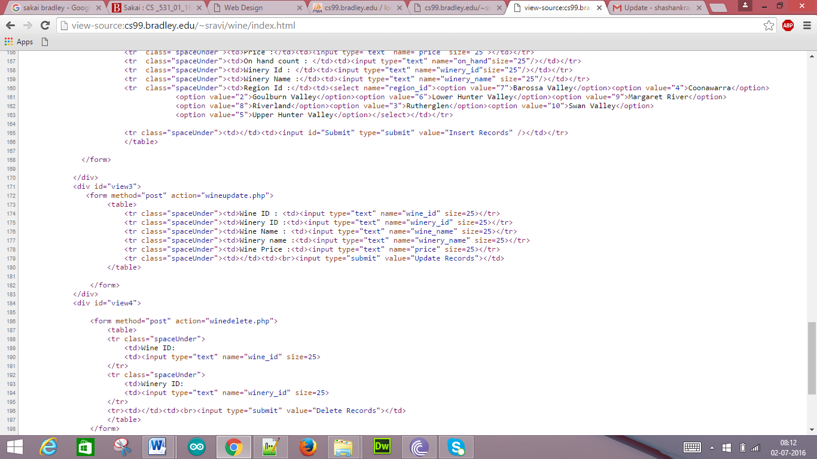

Wine Update PHP Script:

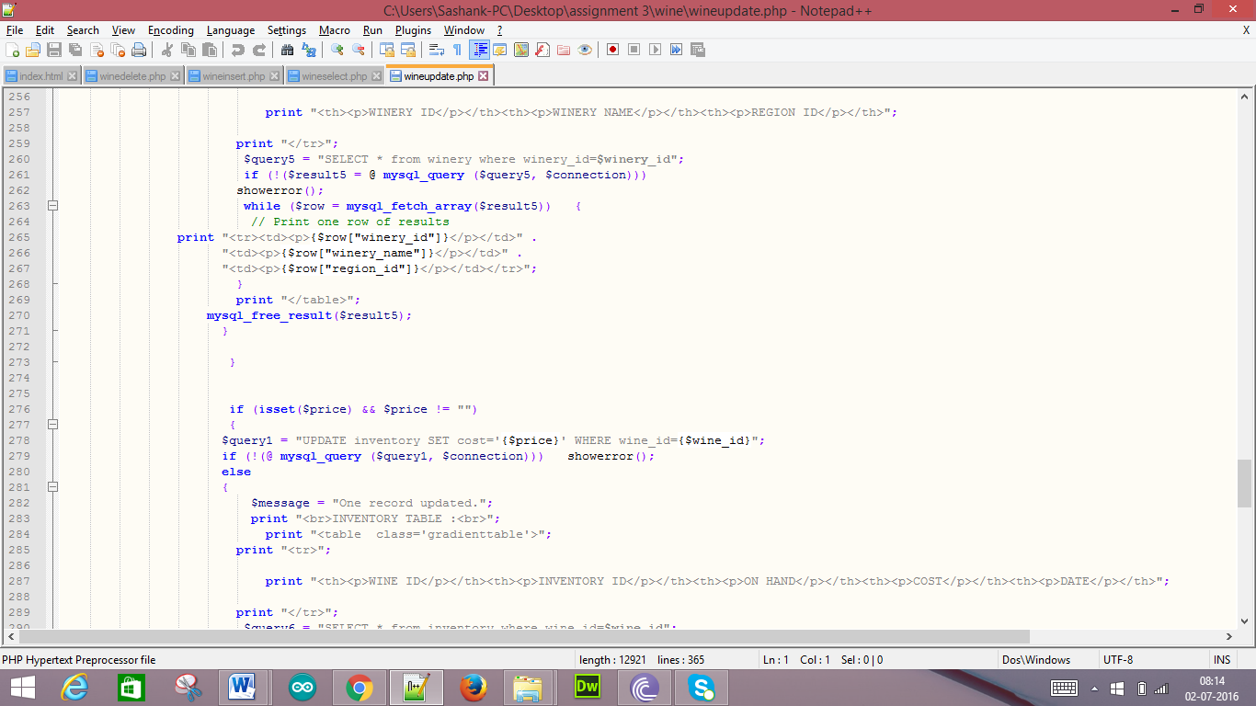

Wine Update page without any inputs provided:

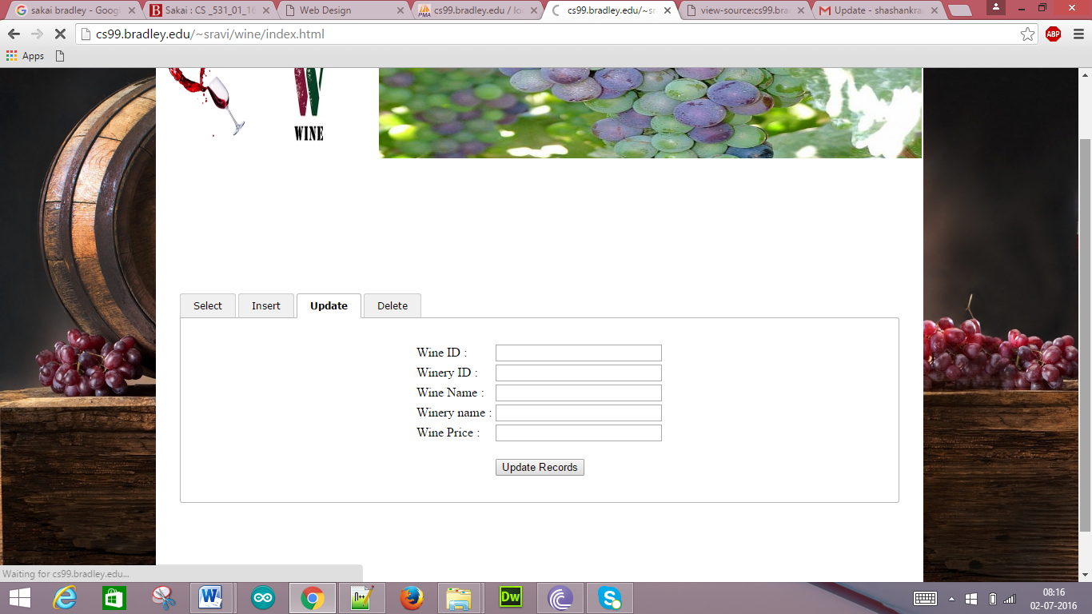

After providing the following inputs:

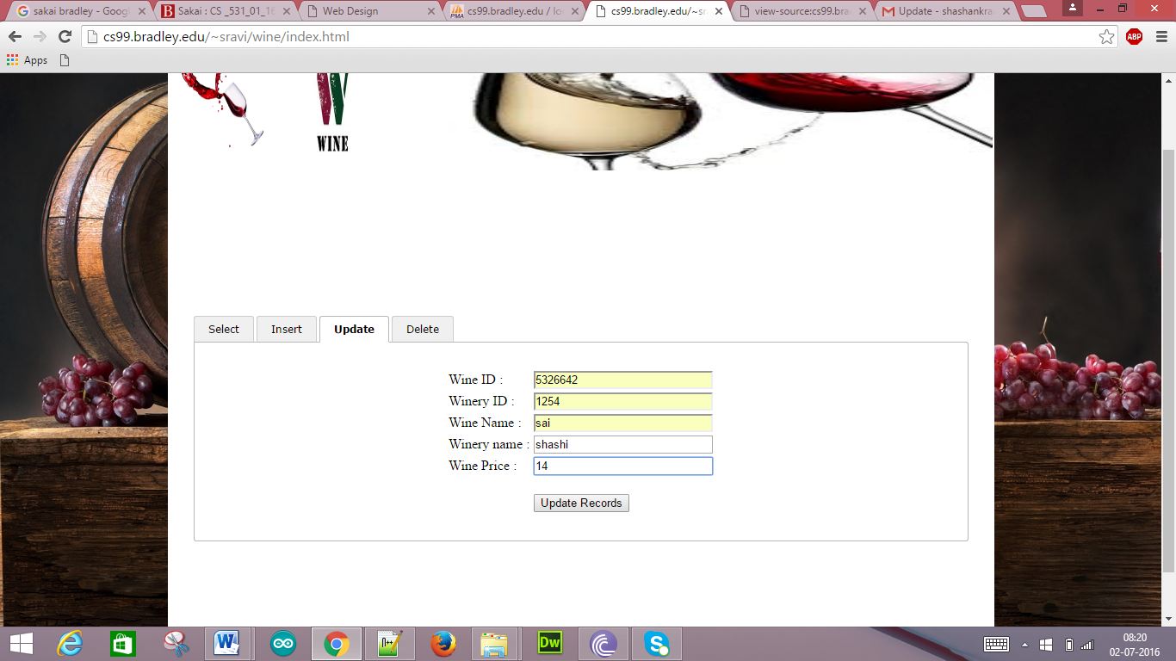

We get the following information:

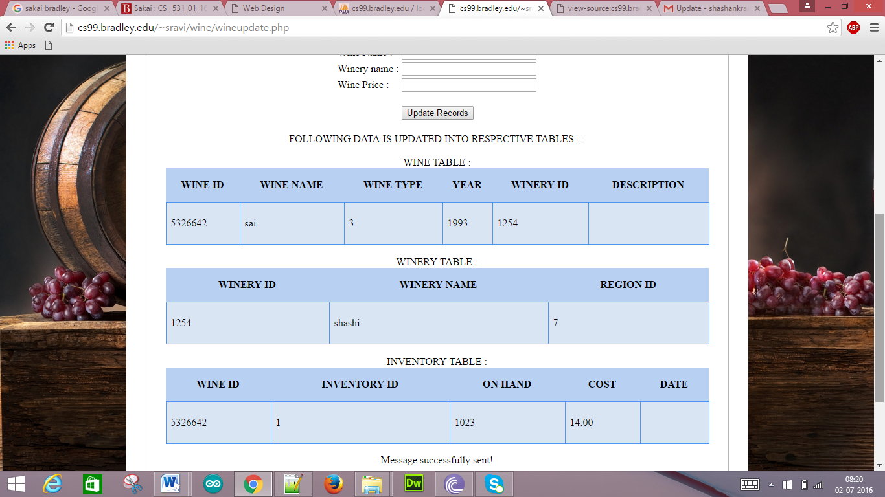

The Data that has been updated is as shown in the last row of the table:

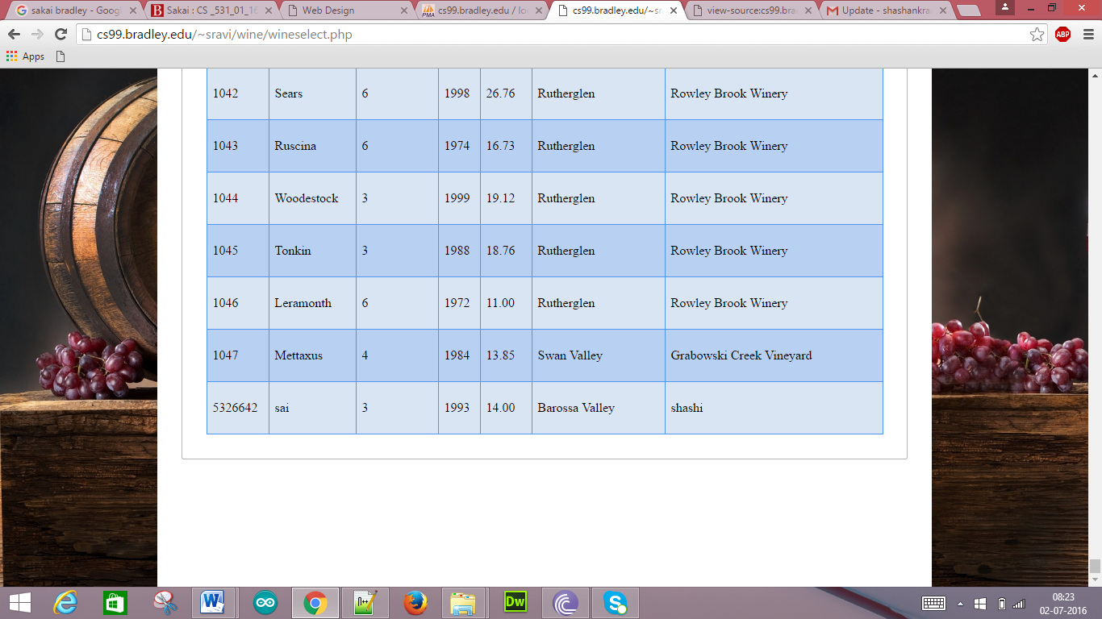

We also get the Email confirmation for this Update:

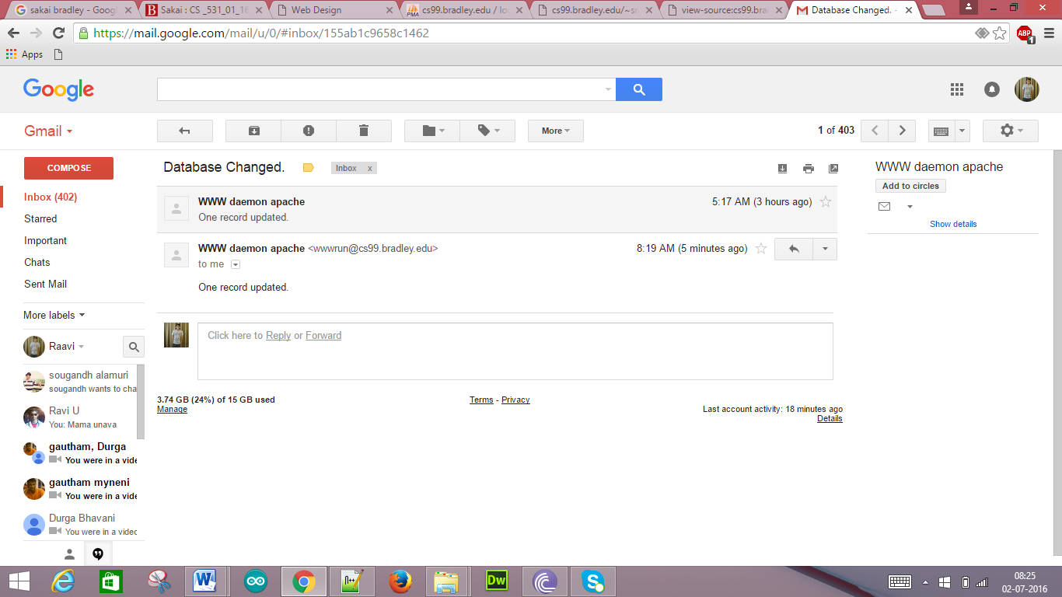

iv) Wine Deletion:

Wine Delete HTML Code:

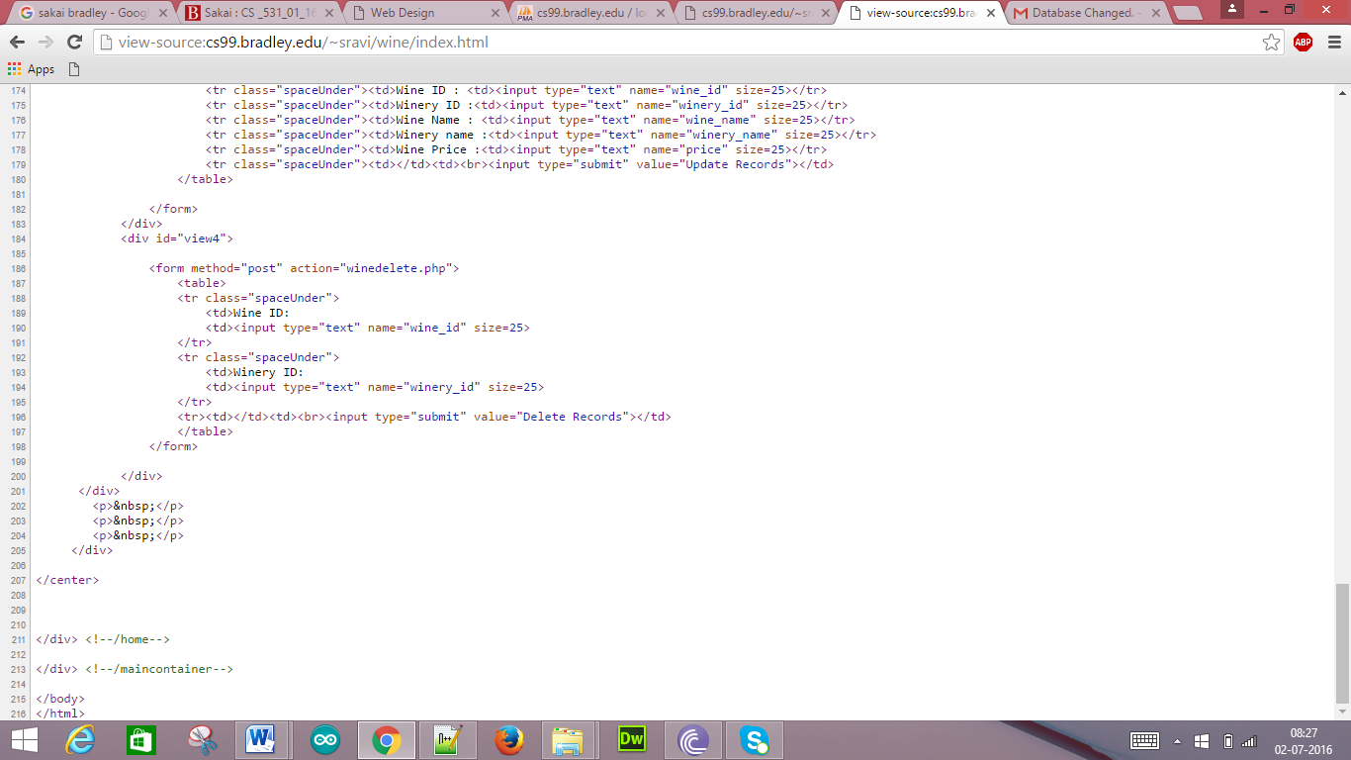

Wine Delete PHP Script:

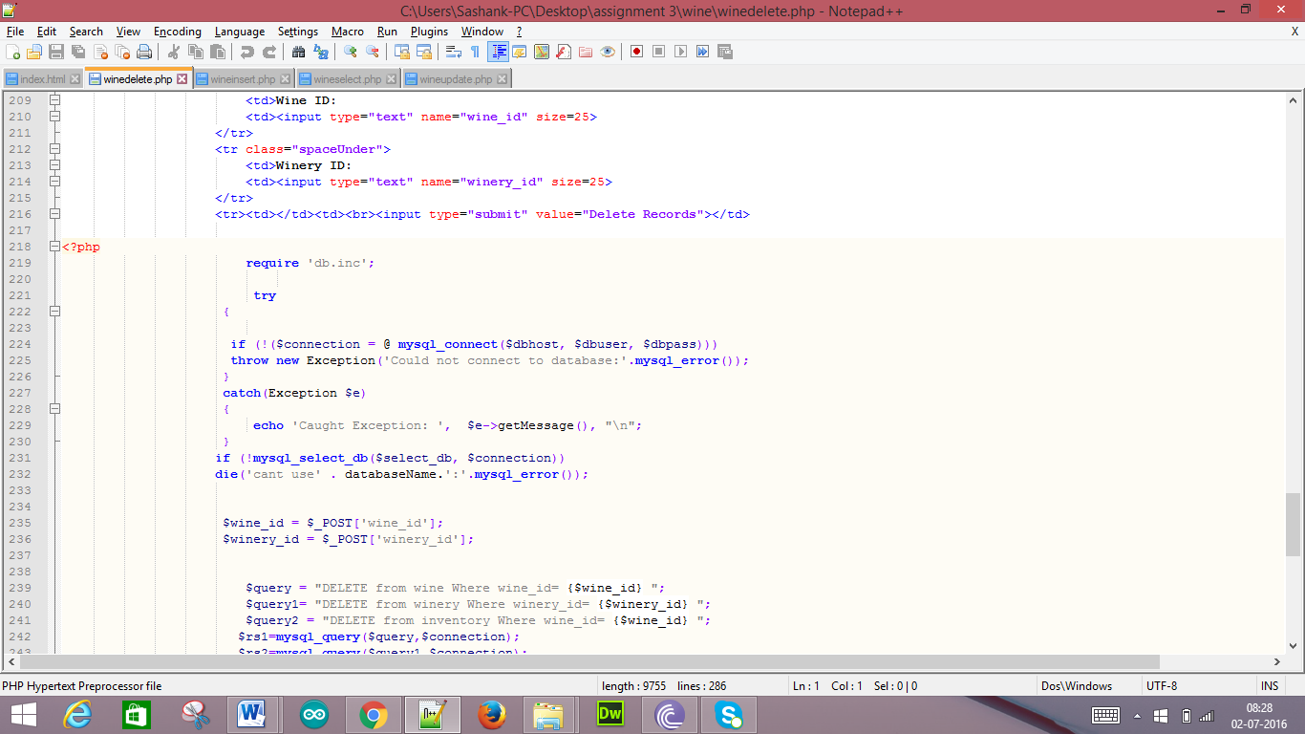

If we want delete the Wine ID: 5326642 which is as shown:

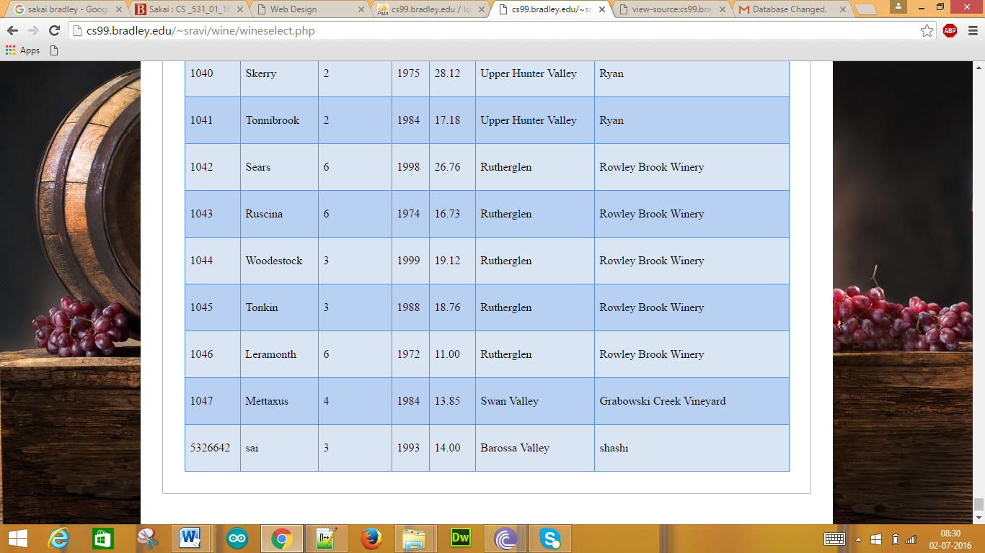

Wine Deletion page without any inputs:

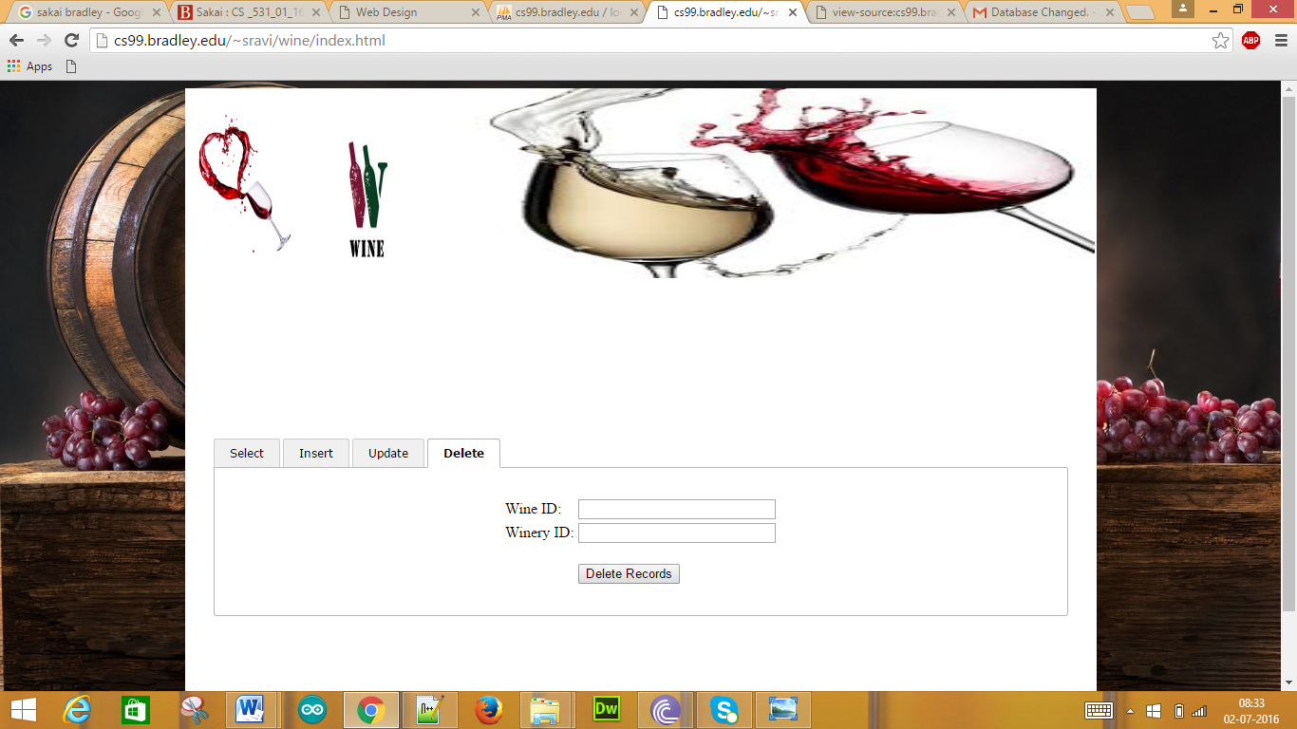

When we provide the inputs in the fields:

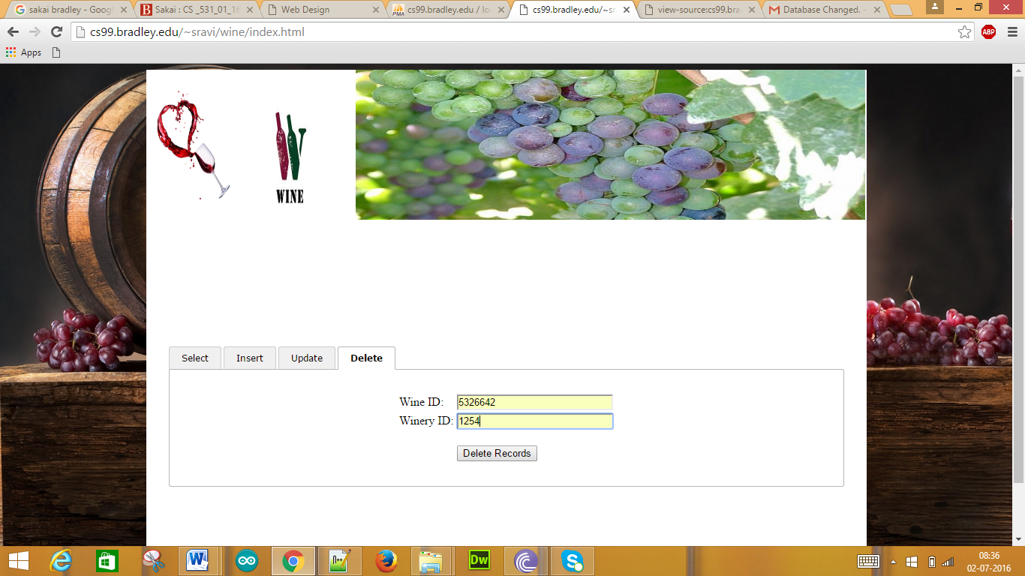

We get the following display for the input which we have given for deletion:

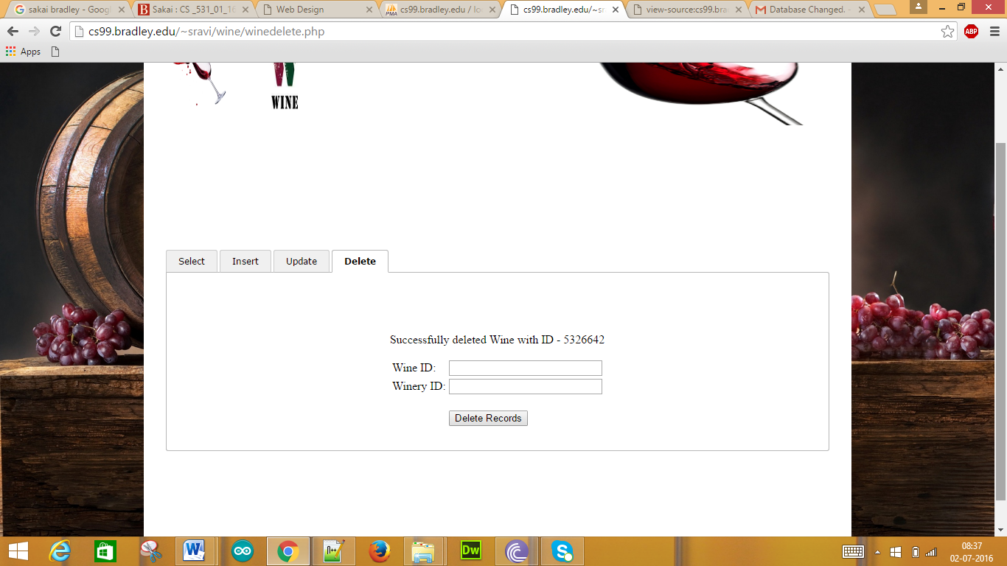

After deleting the Data which is given as input when we check the database it will be as such:

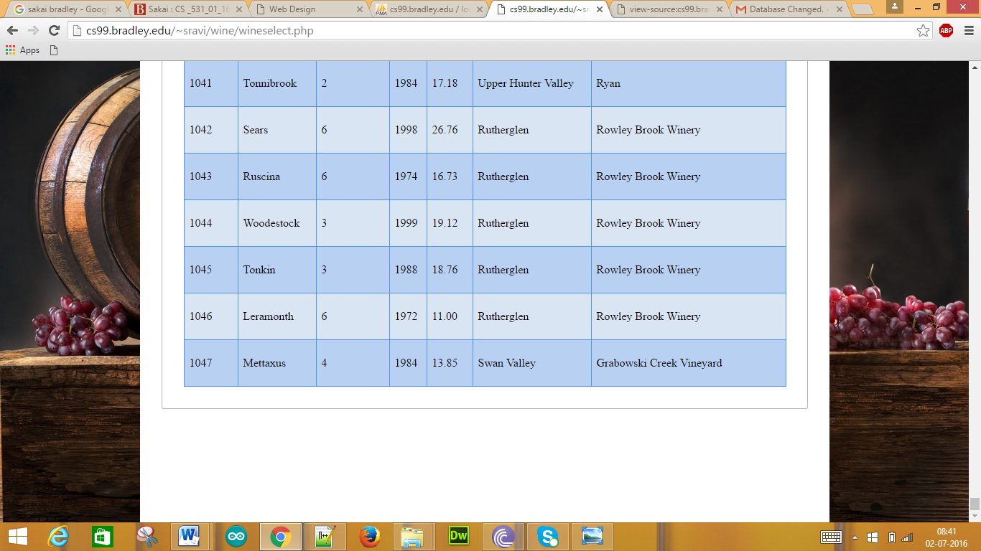

Entity-Relationship Diagram:

